Design Doc

# Team stack

|  |  |  |  |  |  |
| --- | --- | --- | --- | --- | --- |
| Mini Game Team | Technical Art | VR Team | Gameplay Oversight | UI/UX | Audio |
|  |  |  |  |  |  |

# Scope

The game is a VR horror, it implements mini game mechanics around a house that consists of 4 different rooms which will be investigated – meaning there should be core minigames and designs of 4 rooms; each room will contain a phone which will have a ringing sound effect that will inform the player of the chosen room’s mini game. There will be ringing from these 4 phones at separated times which the player will use said sounds to identify the room areas. Each completed room minigame will give player a key for progression onto the second room. Aim of game is to collect all the keys to escape.

# Mechanics

1. **SOUND BAR:** Due to its horror genre, the game implements a sound bar mechanic which is essentially a sound bar that will present to player how loud or quiet the sound they are making is;
2. We will create an illusion that a monster is following the player, using silhouettes when they turn around and noises. the monster has a fear of sound so the player can protect themselves by picking up items in the corridors (e.g. glass, pots and ornaments) and smashing them against the floor of walls to produce noise.
3. For example, if the player is not making enough noise the monster will feel closer, triggering sound effects etc. If the sound bar goes all the way down, then a jump scare will be triggered on the players screen ending the game.
4. The sound bar will be displayed on tables or on shelves around the corridors so the player must look around to see how much noise they are making.

The breakable items will be hidden in places so the player is required to search the areas rather than smashing and moving past too quickly which takes away from the horror experience. This mechanic is only present in corridors – in rooms you can have a break.

1. **CANDLES:** The game is also aesthetically dark, so the player will only have candlelight to light their path, this candle will be given to the player at the beginning in their room and the player will be required to use said candle to light up others in the corridors and replace the candle you were using prior – if the lights go out, or you do not make any noise, it is a game over.
2. **MINIGAMES/PHONE:** There will be 4 rooms each with 4 minigames; each room greets the player with the ringing of an unplugged phone to which the player will need to answer; after answering, the phone will inform the player of the minigame and progress the game’s storyline. The phones will be ringing at a distance to allow the players to navigate and find the rooms, they will ring every 15 seconds. The house also has rooms that can be opened to add further need for the player to investigate properly.

Once you enter the room using the key you find from the previous room, you will be greeted with the phone ringing, which isn't plugged in... But anyway, you answer the phone, and it explains the mini game and continues the storyline. The mini game's purpose is to get the key for the next room. The mini games will be suited for VR, I've done some research on VR mini games that won't be too complicated but fun. I don’t want the mini games to be too hard so you can get back to the corridors. the mini games will include Whack a mole, stacking items, a ball unblocking game and buzz wire.

# Game engine and release

Unreal Engine 5.0.3; this is due to the VR development process and how Unreal have VR development features already which can boost productivity in the production of this game; Unreal also has lighting systems that help with the aesthetics of the game. The game will be released on Steam VR and Oculus Quest.

# Art style

Low Poly model style and a grey dark colour pallet; use a lot of greys for the floor and furniture and brown and dark green for the walls. And the accent of the orange from the candlelight.



References:

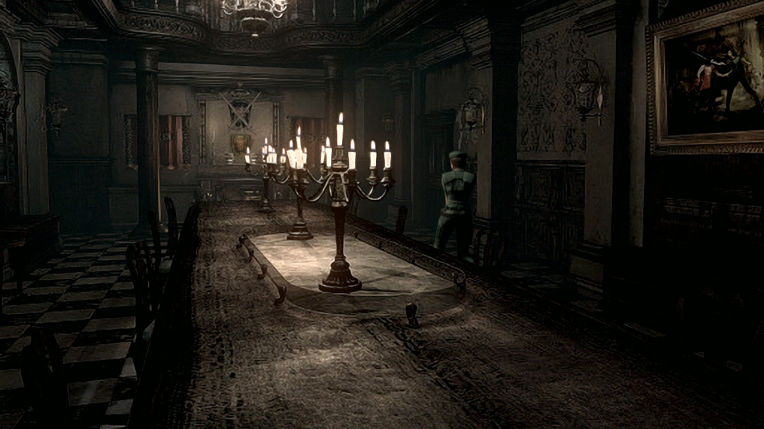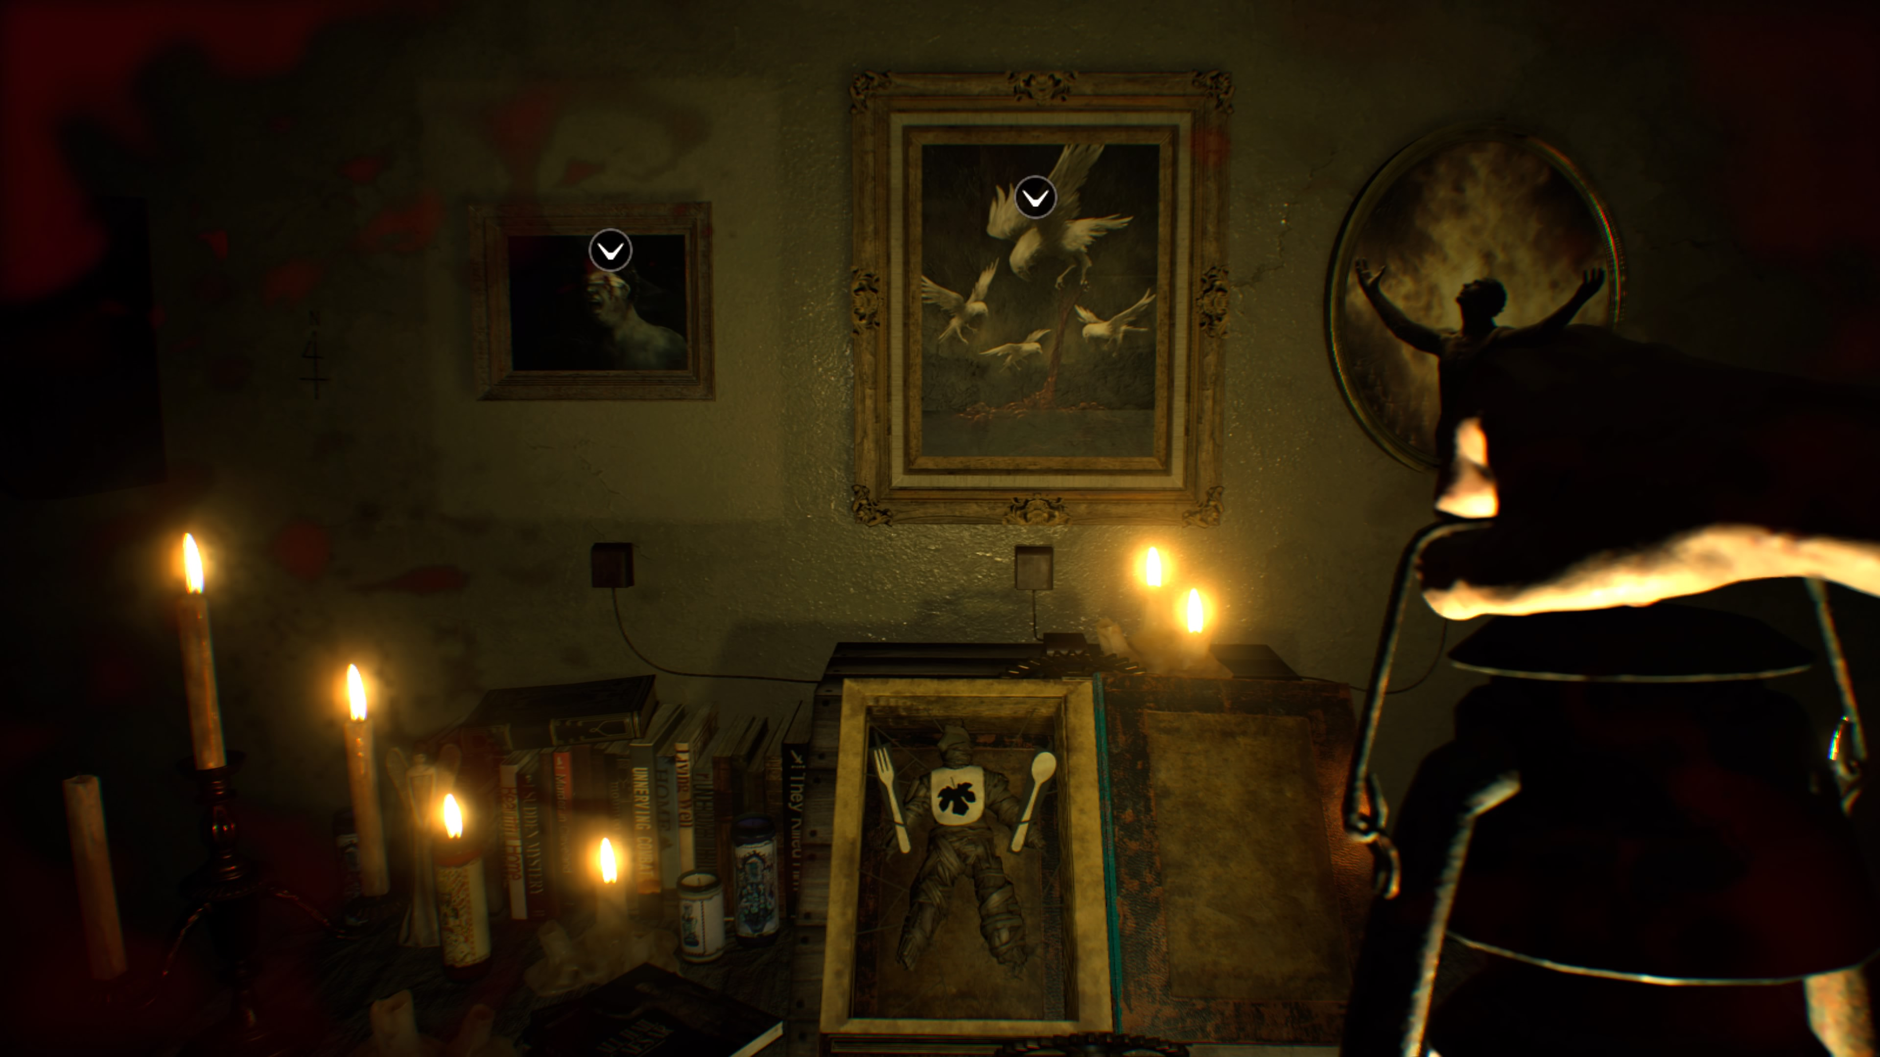

# Gameplay (progression/narrative)

* **Game Progression** – The game starts in the man's bedroom, you hear knocking on the door, you light a candle and make your way to the door. You enter the corridor, and no one is there, then the game begins. You hear a phone ringing and make your way towards it. Lighting candles and making as much noise as you can along the way.
* **Game Narrative** – You play as a troubled young man whose whole life has been a back a fourth battle, loss of family members and failed dreams. He’s always felt trapped in his own head, self-doubt and no motivation. This game is based in a dream, a dream where he is battling his own sub conscious, the "monster" is really his self-doubt and making noise by smashing things is a metaphor for distractions in real life like partying and alcohol, so the self-doubt doesn’t catch him.

# Replay ability

At release:

* Different difficulties
* Multiple Easter eggs
* Different achievements to unlock.

Over Time:

* More game modes
  + E.g. Multiplayer and a scavenger game mode where you must find different items/ objects around the map and pick them up to complete tasks and earn in game currency for cosmetics.
* Combat with online players also searching for that item/ object.
  + The combat will involve throwing objects around the house at each other such as glasses and pots etc.

# Timescale/product management

* We have 9 weeks for development, the team will be working 5 days a week from 9 – 5
* We aim to have the game at a high standard by week 7, then preparing for release by polishing bugs etc. in the last 2 weeks.
* Prioritize organization and efficiently by using the Kanban Vision wall. We will be using Trello as it’s a free online software that the whole team can add to and change. As The team is quite large with a total of 28, a board that every team within the team can access means that they can all work on their separate tasks at once and push it through GitHub.

Here is a timeline of how this will be visualized:

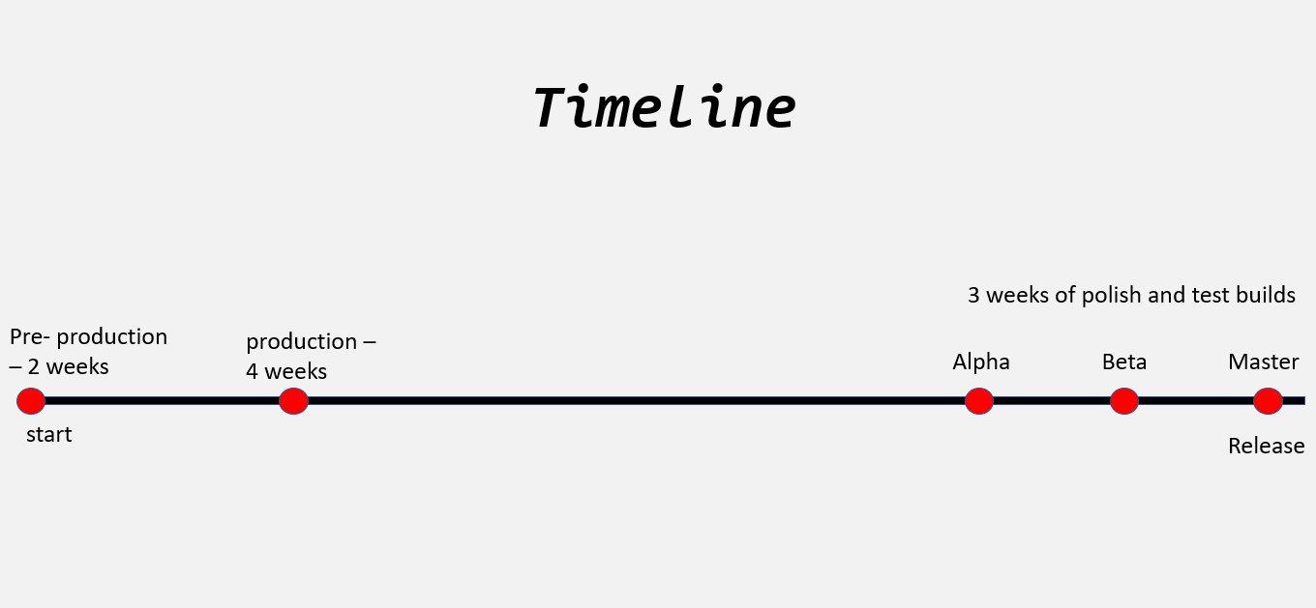

# Target market

The target market for Shush will be young adults, doing market research we have found horror is popular with young adults aged 18 - 25. We have also researched the most popular age range for owning a VR headset, that being teenagers and young adults ranging from 15- 25. We aim to capitalize on this by creating engaging trailers and artwork.

